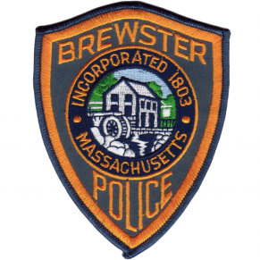
Brewster Police Youth Academy
August 22nd-August 26th
Brewster Police Dept.
631 Harwich Rd.
Ages: 7-12
9:00am -11:00am
This is a FREE Program
Calling Brewster school youths ages 7 through age 12 for the Brewster Police Junior Academy August 22nd through August 26, 2022, at Brewster Police Department. Preference given to Brewster residents, limited to 15 students.
If you have wondered what it is like to be a police officer, then sign up for a week of fun filled activities which includes:
• Tour police Station
• See police vehicles
• Handle police equipment
• Meet members of the department
• And much more

Students Name: _________________________________________________
Parent/Guardian contact info: Name: _________________________________________
Address: _______________________________________
Phone #________________________________________
Email: __________________________________________

For more information contact: Lt. Charles Mawn (508) 896-7011 or cmawn@brewster-ma.gov

