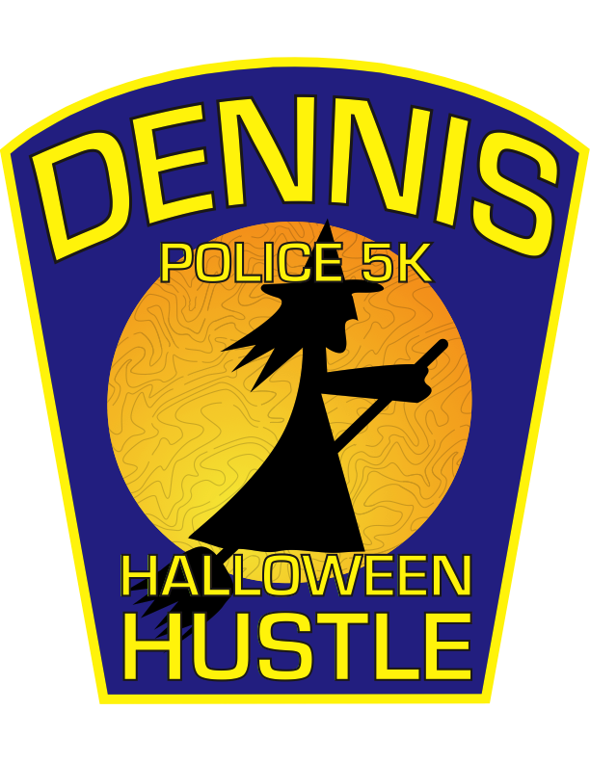

7th Annual Dennis Police 5K: Halloween Hustle Run/Walk
Sunday, October 28, 2018 11:00AM
Starts and Finishes at Mayflower Beach, Dunes Road
Dennis, MA02638
Register online atwww.dennispolice5K.org

Awards for: Top 3 Finishers in Each Age Group ~ Top Male/Female Police ~ Top Male/Female Fire
Professionally timed by RaceWire time chip technology ~ Moderate course along the historical section of Dennis
Halloween costumes encouraged ~ Costume contest open to all following race ~ Private after party at Chapin’s
After party free with race number

Event Benefits: The Dennis Police Association

……………………………….…………………..Cut Along This Line and Mail with Check………………………………………..
7th Annual Dennis Police 5K: Halloween Hustle ~Please Print~

First Name: ___________________________________________M.I. _____________Last: ___________________________________________________________
Address: ____________________________________________________City: _______________________________________State: ________Zip: ____________
Telephone: (________) ___________-_____________________E-mail: __________________________________________________________________________
Age on 10/28/18: ____________Gender: _______________Check One: Runner: _______ Walker: ________(Walk is non-competitive)
Police or Firefighter, please check here: ____________ Agency/Dept: ______________________________________________________________
Entry Fee: Adults_________ $20 or __________ $25 Race day Students(11-18 yrs old) ___________$15
Please makes checks payable to and mail to: The Dennis Police Association, P.O. Box 672, South Dennis, MA02660
Attn: Dennis Police 5K
Please read before signing:
In consideration of acceptance of my entry the undersigned hereby, for myself, my heirs, successors, assigns, executors, and administrators hereby waive and release all claims for damages for injuries or any other loss which may arise or result from my participation in the Dennis Police 5K: Halloween Hustle (the “Event”) against the following entities and parties: The Dennis Police Association, Town of Dennis, Event sponsors, Event charitable beneficiaries, Event volunteers, including with respect to each of the foregoing their representatives, successors, agents, employees, servants, directors, and officers (collectively the “Released Parties”) including such injuries caused by the negligence, gross negligence, or other fault of the Released Parties or any one of them. I understand that participation in road race events is an inherently dangerous activity with a risk of serious injury or death. I represent that I am physically fit and sufficiently trained to safely participate in and complete this Event as a foot race entrant, and that a licensed physician has verified my fitness for this Event. I hereby authorize the Released Parties to use my likeness in photographs, motion pictures, video, or digital recordings, or any other form of video or audio recording for the purpose of reporting or promoting this or similar events.

X ___________________________________________________________Date: ______________________________________________
Signature of participant or parent/guardian if under 18 years

